Install Python for Helix_app
-----Reference Link-------
https://www.digitalocean.com/community/tutorials/how-to-install-python-3-and-set-up-a-programming-environment-on-an-ubuntu-20-04-server

1) sudo apt update

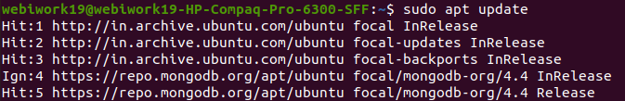
e
2) sudo apt -y upgrade

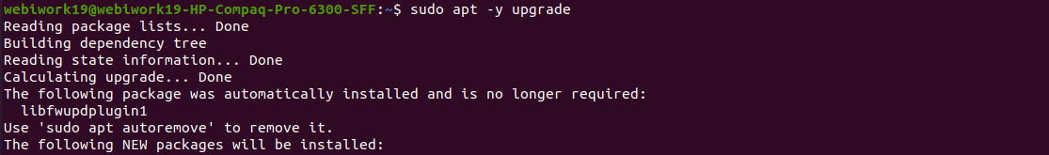
3) python3 -V
4) sudo apt install -y python3-pip
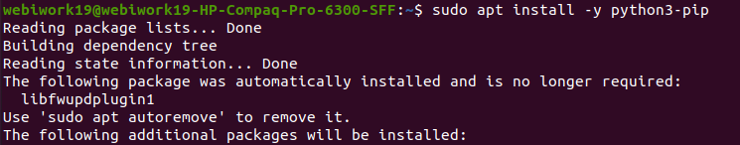

5) pip3 install package_name (There are 13 packages of pip3 as below)

i) pip3 install pystan==2.19.1.1

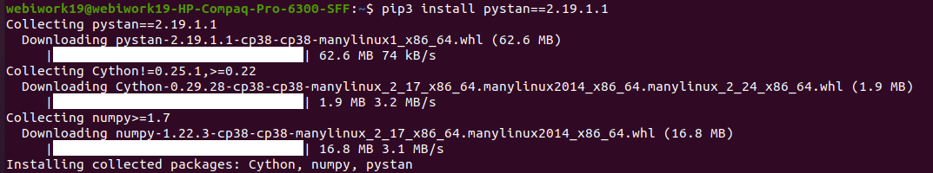
ii) pip3 install boto3

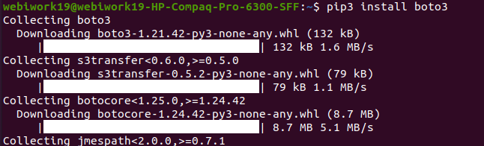

iii) pip3 install whois
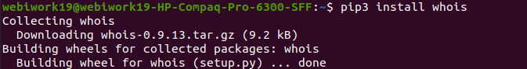
iv) pip3 install pandas

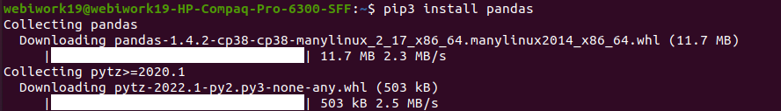
v) pip3 install numpy

vi) pip3 install json
// If its show that type of error dont worry . all good and code will be run successfully.
vii) pip3 install prophet

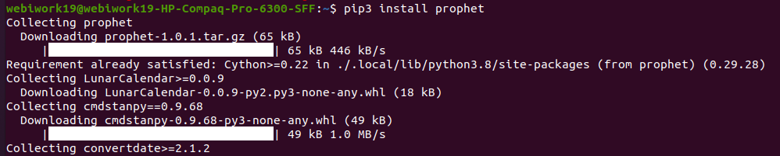

viii) pip3 install django

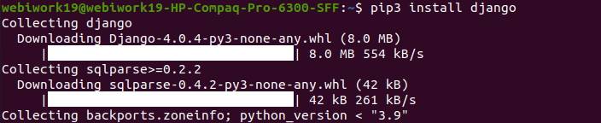
ix) pip3 install crypto

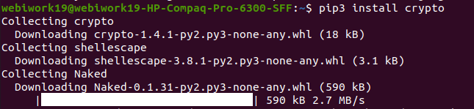
x) pip3 install pyOpenSSL

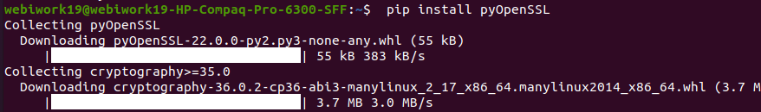

xi) pip3 install AWSIoTPythonSDK

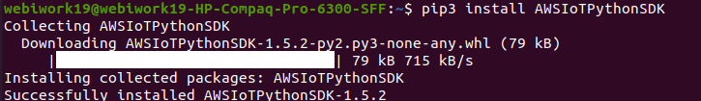

xii) pip3 install plotly

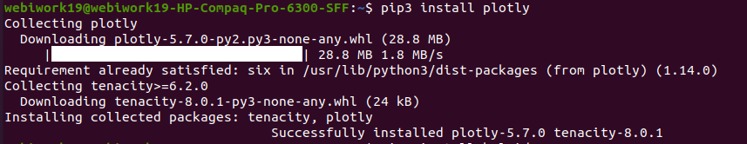
xiii) pip3 install kaleido
(xiv) pip3 install azure.iot.device

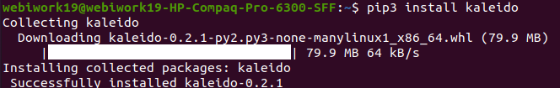

After all packages install successfully , we will move on next step i.e. clone project from git.

1) git clone https://github.com/AdvancedManufacturingTechnology/iot_server_Anik.git;

2) cd iot_server_Anik // in iot_srever two folder there ls
i) helix-app
ii) server

3) git branch

i) cd helix-app/
* npm install // for node modules
run code by this command - npm run dev-start

//in terminal new tab
ii) cd server/
* npm install // for node modules
run code by this command - node index.js

And also git clone for admin dash--->

1) git clone https://github.com/jss-codd/helix_admin_dashboard.git

2) cd helix_admin_dashboard/

3) npm install

4) git branch

5) git checkout <branch_name>

run code by this command - npm start

